Assignment
Module 10: infrastructure Security an WAN Technologies-

13- A Cisco Catalyst switch connects to what should be individual user PCs. Each port has the same port security configuration, configured as follows: interface range gigabit Ethernet 0/1 - 24 switchport mode access switchport port-security switchport port-security mac-address sticky Which of the following answers describe the result of the port security configuration created with these commands? (Choose two)
Answer:
A. Prevents unknown devices with unknown MAC addresses from sending data through the switch ports.
C. Will allow any one device to connect to each port, and will save that device’s MAC address into the startup-config

14- What is the Administrative Distance of internal EIGRP routes?
Answer: B. 90

15- When a subnet mask is presented in binary, what do the binary 1s represent?
Answer: A. The network portion of an associated address

16- Which switch would STP choose to become the root bridge in the selection process?
Answer: A. 32768: 11-22-33-44-55-66

17- Which of the following devices is used by the service provider to provide WAN services?
Answer: B. Core router

18- Your Cisco IOS router is acting as a DHCP server. Which command will display the addresses that have been handed out to clients on the LAN?
Answer: D. show IP DHCP bindings

19- Which of the following commands would you use to enable EIGRP only on those interfaces with an IP address from 10.1.1.0 through 10.1.1.63?
Answer: A. network 10.1.1.0 0.0.0.63

20- R3 has a static route configured that points toward the service provider. What command could you use to have R3 advertise an OSPFv3 default route to the internal network, regardless of whether R3 had its default static route?
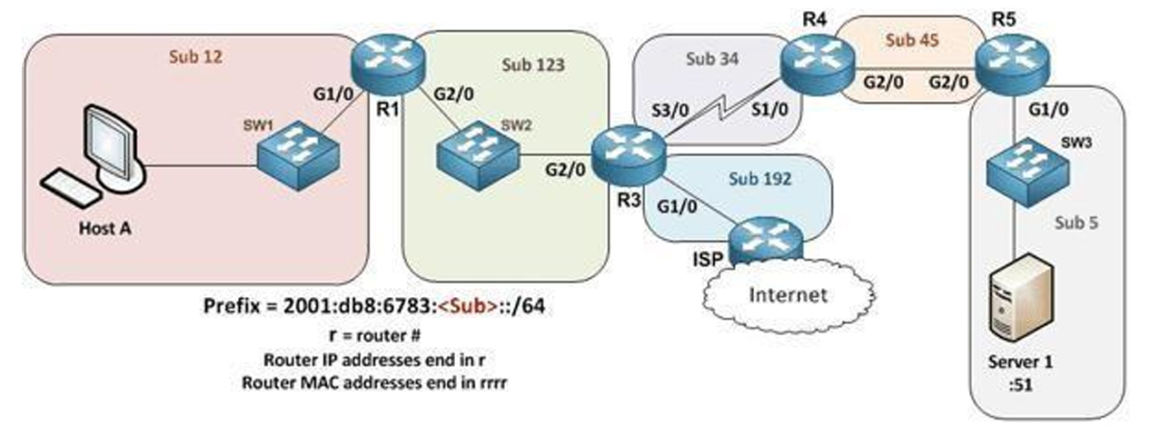
Answer: E. Have R3 use the command default-information originate always in OSPFv3 router configuration mode.

21- You are configuring dynamic NAT on your Cisco IOS router. Which command is used to verify the interfaces that are being used as the outside interface and the inside interface?
Answer: D. show IP interface brief

22- When using the “show EtherChannel summary “command, what does the “u “flag signify?
Answer: D. Unsuitable for bundling

23- Which command could you enter to encrypt passwords?
Answer: D. All of the above

24- You are setting up a Cisco IOS router as a DHCP server. Which command is used to identify the IPv4 addresses that will be in the DHCP pool?
Answer: F. IP DHCP pool

25- Which of the following statements are true regarding the processing of ACLs that have been applied to router interfaces? (Choose two)
Answer: A. Inbound ACLs will be processed before the routing table lookup occurs
C. Outbound ACLs will be processed after the routing table lookup has occurred
26- imagine you configured OSPFv2 in a small lab network. Which of the following answers list a condition that could keep the routers in your lab from learning all the routes to all the IPv4 routes in your small lab network? (Choose two)
Answer: A. An ACL could be blocking router advertisements.
C. Any physical layer problem that would prevent two neighbouring routers from being able to ping each other’s IPv4 addresses in the subnet that exists between the two routers.

27- Which statements describe neighbour discovery functionality in IPv6? (Choose two)
Answer: A. Determines the link layer address of a neighbour
D. Queries for duplicate addresses
28- Which IPv6 prefix will the typical enterprise network receive from the service provider?
Answer: B. /56

29- How should be configured a switch so that it could be accessed remotely?
Answer: B. Apply the access control list, or ACL, to the virtual type terminal, or vty, lines

30- Refer to the exhibit. A network technician is asked to design a small network with redundancy. The exhibit represents this design, with all hosts configured in the same VLAN. What conclusions can be made about this design?
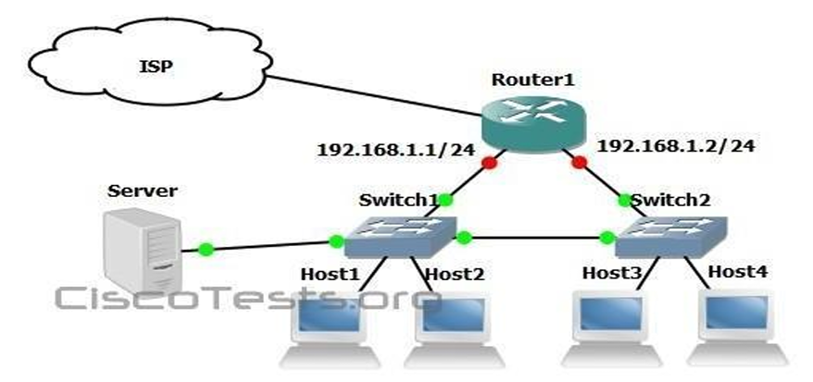
Answer: B. Spanning-tree will need to be used.

